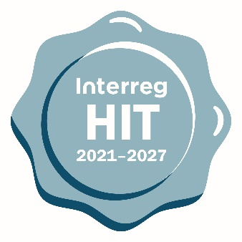

Harmonised implementation tools

Project and project partner

statements

(Final version 1.0 - September 2021)

This is a Project and project partner statement document for standard projects applying for funds in any Interreg strand.

The main objectives of this document are:

* to confirm the availability of funds from prospective partners in the project
* to ensure compliance with wider legal framework (procurement, GDPR)

To reach a high level of harmonisation, the HIT tools should be used as much as possible as they are. The tools have been designed based on an agreed structure that avoids asking for similar information in different contexts.

If needed, the following flexibility principles can be applied:

* It is possible to change the order of main parts or questions within each part.
* Changes that don't disrupt the main logic of sections/questions are possible. The logic can be disrupted when one change influences some other part(s) of the tool.
* Optional questions (in yellow) can be left out partially or in full.
* Multiple languages are possible by adding fields to enter the text in other languages.

Project statement

Purpose and logic:

* This section contains elements needed to confirm project's understanding of and compliance with the wider legal framework
* This template can be turned into an online form in monitoring systems or be uploaded in the relevant section of the online systems

-----------------------------------------------------------------------------

By signing the application form, the lead partner on behalf of all partners confirms that:

* the project respects the EU requirements for joint development, joint implementation, joint staffing and joint financing;
* the project, neither in whole nor in part, has or will receive any other additional EU funds (except for the funds indicated in this application form) for the activities indicated in the application form during the duration of the project;
* the project has not been fully implemented before the submission of this application;
* the project partners listed in the application form are committed to take part in the project’s activities and financing;
* the project is in line with the relevant EU and national/regional legislation and policies of the regions and countries involved;
* the lead partner and the project partners will act according to the provisions of the relevant EU regulations, the specific provisions of the programme and national rules, especially regarding structural funds, public procurement, State Aid, equal opportunities and non-discrimination and sustainable development, and has no harmful impact on the environment;
* the information in the application form is accurate and true to the best knowledge of the lead partner.
* All natural persons participating in the project and project activities have in advance given their consent to the collection, recording, storage and transfer of their personal data in databases of the programme authorities and management bodies, as well as data transfer to third parties identified in *[insert programme name]* 's privacy policy (e.g., European Commission), in accordance with the provisions for data transfer and data processing described in Regulation 2016/ 679 (General Data Protection Regulation/ GDPR).

Project partner statement

In the event of approval of the above-mentioned project applying to the [*insert programme name*] the [*insert the partner number and name of partner organisation (in English)*]*:*

1. commits itself to the project and the activities laid down in the application form, and intends to provide the total amount of EUR *[insert amount]* as contribution to the project’s budget.
2. is aware of the programme rules on reimbursement and confirms the availability of own resources for pre-financing the activities and understands what its role will be in the project;
3. declares that it is not under a bankruptcy proceeding, bears full legal capacity and is financially reliable, and that its foundation and activities are in line with the respective national legislation;
4. confirms that no expenditure related to the above-mentioned project has been, is or will be funded, in part or in whole, by any other EU-funded programme;
5. declares to accept all obligations as a project partner deriving from the subsidy contract, which will be signed by the lead partner of the project after the approval, as well as the project partnership agreement which will be concluded between all partners participating in the project;
6. commits itself in complying with the relevant public procurement rules (internal, national, European and programme specific rules if existing) and in making the results available to the public.
7. the information in the application form is accurate and true to the best knowledge of the project partner.
8. VAT STATEMENT

declares that **only** **non-recoverable VAT is included** in the partner budget and declares that the **non-recoverable VAT** is borne by the partner as final beneficiary; OR

declares that **recoverable VAT is not included** in the partner budget and is aware that **recoverable VAT** will not be eligible for reimbursement

declares that **VAT can be partially recovered** in our organisation and that the recoverable part is not included in the partner budget as it is not eligible for reimbursement.