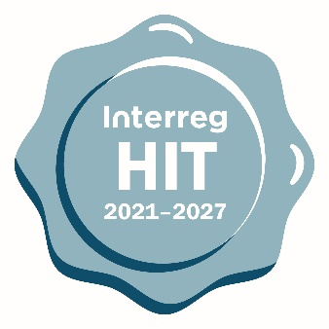

Harmonised implementation tools

Supplementary information

section

(Final version 1.0 - September 2021)

This is a Supplementary Information Section document for standard projects applying for funds in any Interreg strand.

The main objective of this document are:

* to gather information normally needed for each project. It is the type of information that is not needed or available at the application stage, and it doesn’t concern every progress report.

Information might change during the implementation, for various reasons. These changes usually don’t affect project implementation and might not require an official change procedure.

Each programme can decide in which section of their monitoring system the project will need to enter this information. It is also not necessary to ask for all information listed below, and more of this type of information can be added.

To reach a high level of harmonisation, the HIT tools should be used as much as possible as they are. The tools have been designed based on an agreed structure that avoids asking for similar information in different contexts.

If needed, the following flexibility principles can be applied:

* It is possible to change the order of main parts or questions within each part.
* Changes that don't disrupt the main logic of sections/questions are possible. The logic can be disrupted when one change influences some other part(s) of the tool.
* Optional questions (in yellow) can be left out partially or in full.
* All overview tables can be customised. These are tables that take data from different fields to present this data in different combinations.
* Multiple languages are possible by adding fields to enter the text in other languages.
* Maximum length of text for answers will be decided by programmes because this depends on technical options in their online monitoring system. Some recommendations are given where relevant.

Project Information

Purpose and logic:

* It is possible to add or remove elements in this section as long as doing so does not disrupt the logic of the form or data flows.

|  |  |  |
| --- | --- | --- |
| Project start date |  | *DD/MM/YYYY* |
|  |  |  |
| Project end date |  | *DD/MM/YYYY* |
|  |  |  |
| Project website |  |  |
|  |  |  |
| Bank details of lead partner |  | *Bank name and address, account number, IBAN, SWIFT, account holder* |
|  |  |  |
| Bank details of project partner (s) - OPTIONAL |  | *Bank name and address, account number, IBAN, SWIFT, account holder* |
|  |  |  |
| Project manager |  | *contact details (name, e-mail address, telephone)* |
|  |  |  |
| Project finance manager |  | *contact details (name, e-mail address, telephone)* |
|  |  |  |
| Project communication manager |  | *contact details (name, e-mail address, telephone)* |
|  |  |  |
| Location of project partner (s) audit documents – OPTIONAL |  | *Physical (indicate address) / available online* |
|  |  |  |
| Codes of intervention |  | *To be filled out by project OR JS/ MA – programme specific decision* |
|  |  |  |